**FINAL YEAR B.TECH SEMESTER INTERNSHIP REPORT**

A report submitted in partial fulfillment of the requirements for the Award of Degree of

**BACHELOR OF TECHNOLOGY**

**in**

**ELECTRONICS AND COMMUNICATION ENGINEERING**

**By**

**Katikala Bhanu Prathap**

**Enrollment Number: BT18ECE050**

**Under Supervision of**

1. **Divyam Garg,Founder, Shiryam Technologies**
2. **Shirish Garg, CTO,Shiryam Technologies**



**Academic Mentor**

Dr.Mayur R.Parate

Assistant Professor

Signature of the Mentor:

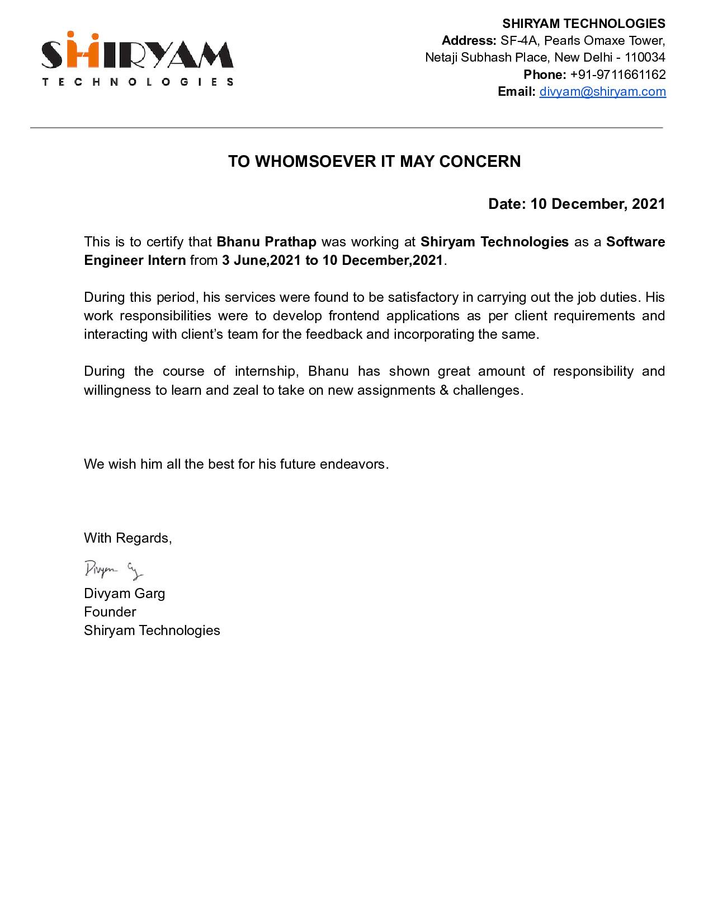



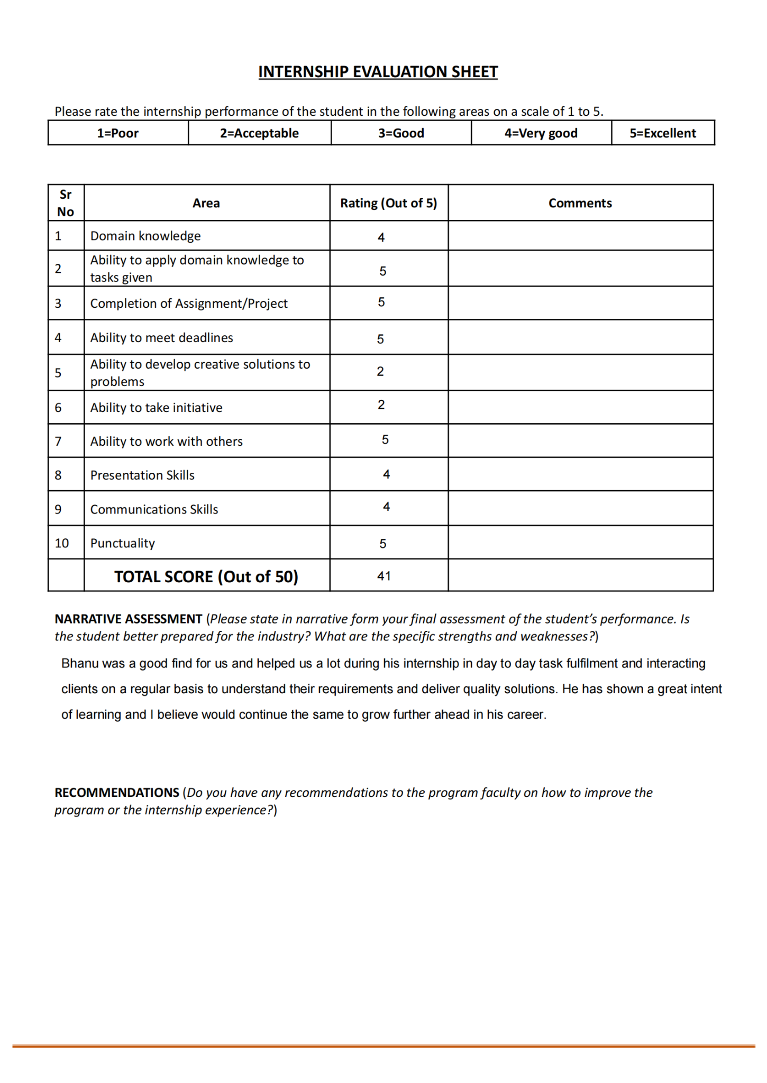

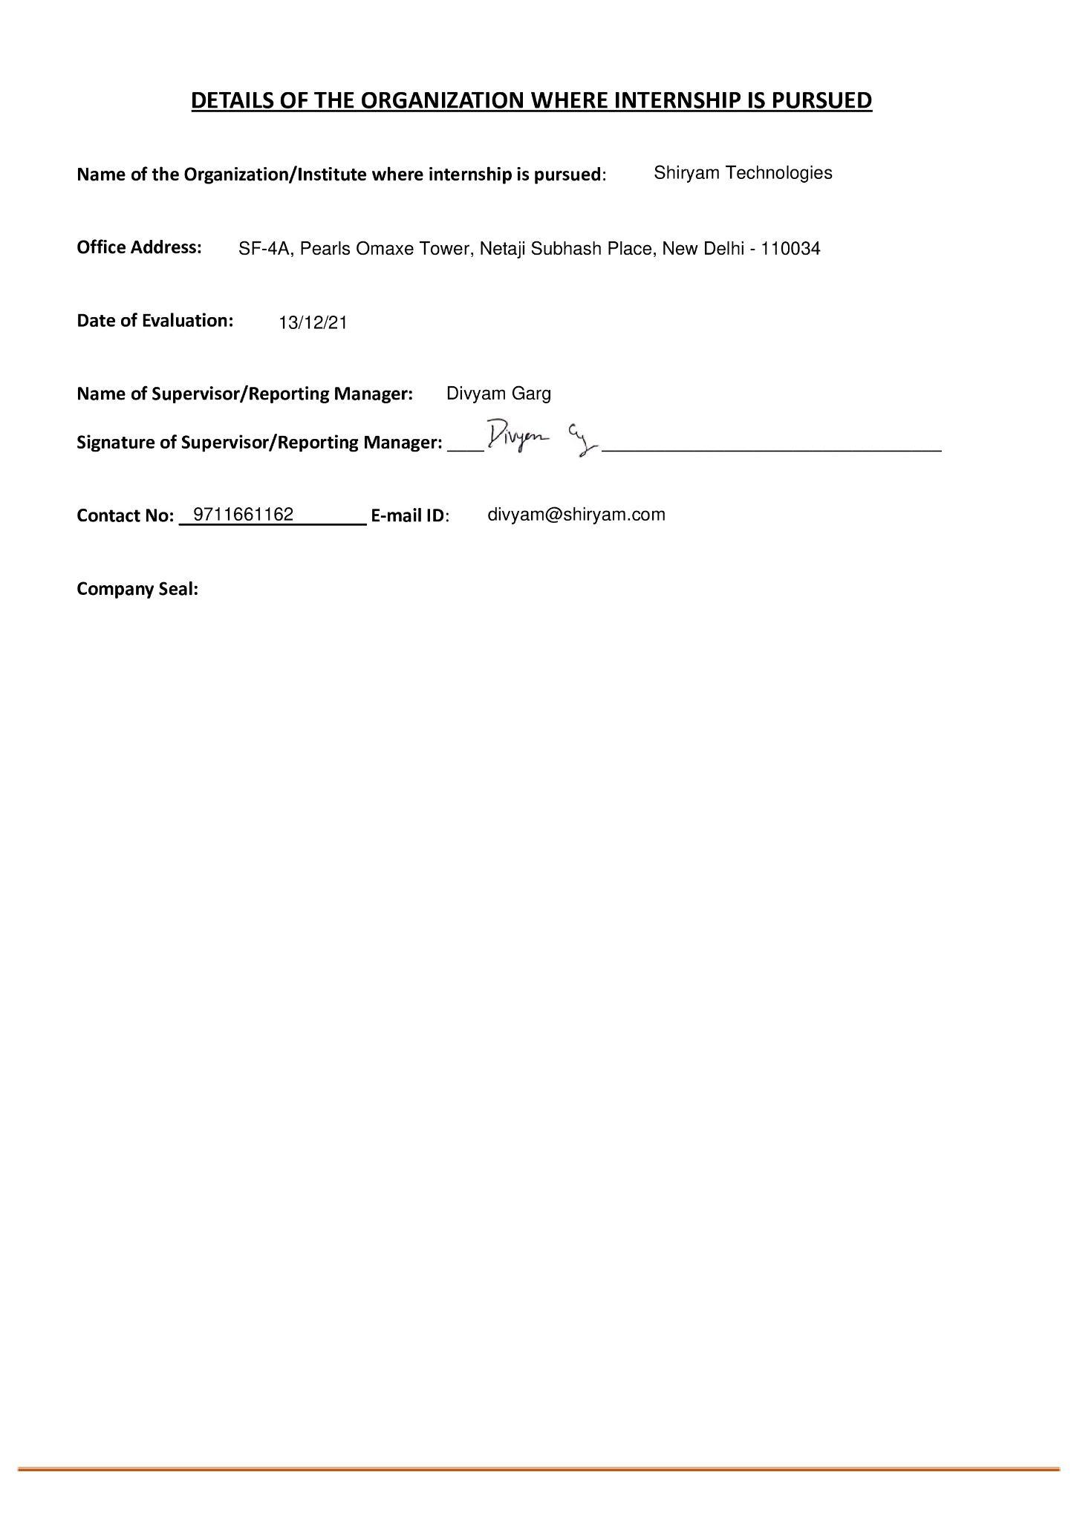

**Acknowledgement**

I would like to express my sincere gratitude to several individuals and organizations for supporting me throughout this Internship.

My profound gratitude goes to our wonderful supervisor, **Dr. Mayur Parate** for invaluable support, patience, time and guidance in seeing me to the completion of this internship. Also my gratitude goes to my manager of internship and founder of Shiryam Technologies **Divyam Garg** who patiently saw me for the completion of this internship.

These 6 months have made me understand my strengths and weaknesses better and closely. And, hence I thank the IIIT​ senate which made the 6-month internship compulsory part of curriculum.

I will strive to use gained skills and knowledge in the best possible way, and I will continue to work on the improvement, in order to attain desired career objectives. Hope to continue cooperation with all of you in the future.

Sincerely,

K Bhanu Prathap

Thanks to all for your encouragement!

**Declaration**

1. I, Katikala Bhanu Prathap, hereby declare that this Internship work as “Software Engineer Intern” is carried out by me at Shiryam Technologies ,Delhi between

3rd June’21 to 10 th Dec’21.

1. The work is original and all details mentioned are true to my Knowledge.
2. The work has not been submitted to any other Institute for any degree or diploma.
3. I have conformed to the Internship guidelines given by the Institute.
4. Wherever I have used materials (data, theoretical analysis, figures and text) from other sources, I have given due credit to them by citing them in the text of the report and giving their details in the references.
5. I have taken the permission from the copyright owners of the sources, wherever necessary.

| **Sr.No** | **Name** | **Enrollment Number** | **Signature** |
| --- | --- | --- | --- |
| 1 | KATIKALA BHANU PRATHAP | BT18ECE050 |  |

**Date:**03/01/2021

**Table Of Contents**

1. **Organization 10** 
   1. Introduction
   2. Business Profile
2. **Internship Profile 11**
   1. What is the role of intern
   2. Responsibilities
   3. Requirements
   4. Desired Skills
3. **Work done in internship 12-19**
   1. Magware
   2. Transreporter
   3. FHM Hot 100
   4. Salt.pe
4. **Technologies used 20-22**
   1. React
   2. Redux
   3. Material UI
   4. Redux Saga
   5. Axios
   6. AWS-Amplify
   7. React-Redux
   8. REST API
5. **Industrial/Commercial Applications 23**
6. **Productivity Tools 24-25**
   1. VS Code
   2. Github
   3. Flock
   4. Adobe XD
   5. Figma
   6. G Suite
   7. Prettier
   8. Github copilot.
7. **Certification/Training Done 26**
8. **Challenges Faced 27**
   1. Fast paced development
   2. Reading Documentation
   3. Difficulty in Discussion
9. **Learnings 28-29**
   1. Team Work
   2. Communication skills
   3. Time Management
   4. Learn Various Frontend Technologies
   5. Version control
   6. Write clean,understandable and maintainable code
   7. Writing tests
10. **References 30**

**Organization Details**



**Name of the company**: Shiryam Technologies

**Company description:**

Our company provides custom software development services to individual clients, start-ups, medium businesses, and large enterprises. Being fully equipped with the latest technologies, we deliver futuristic software solutions to clients globally. We employ a skilled team of UI designers, web and app developers who are totally focused on delivering high-quality software solutions, which enable our customers to achieve their critical IT objectives.

**Business of the company**: Provide the services like Design,Web Development,App Development and corporate solutions.

**Website:**

<https://www.shiryam.com/>

**Email:**

[tech@shiryam.com](mailto:tech@shiryam.com)

**Founded:**

2019

**Portfolio Of The Company:**



**Address:**

SF-4A, Pearls Omaxe Tower,

Netaji Subhash Place,

New Delhi-110034, India

**Description of internship profile**

I Have worked as Software Engineer Intern From 3rd June to 10th December.My day to day responsibilities included developing the User Interfaces and the new features using the React,Redux,Javascript and other frontend Technologies.The Design or mocks are given to us by clients either in figma or adobe xd.Worked on the Bug fixes and written the test cases for components created.

**Responsibilities**

1. Work with the product and design team to design-develop a variety of features and reusable components.

2. Write production quality code in javascript primarily using the React Framework.

3. Analyze and optimize the front-end while pursuing simplicity, efficiency, reliability and performance.

4. Use independent judgment to take existing code, understand its function, and change/enhance as needed

5. Collaborate, provide technical guidance, and engage in design and code review for other team members

**Technical Description of Project**

**Minor projects:**

**Magware:**

Magware is a cross-platform, self-service, global digital magazine newsstand.

So I was given a task of converting the designs into actual web pages and I have used the React js and Material UI For completing the task.As It was my first task it took sometime to understand the software development process and eventually completed the task.

In this task I was asked to integrate the Rest API From backend for fetching new users who sign.

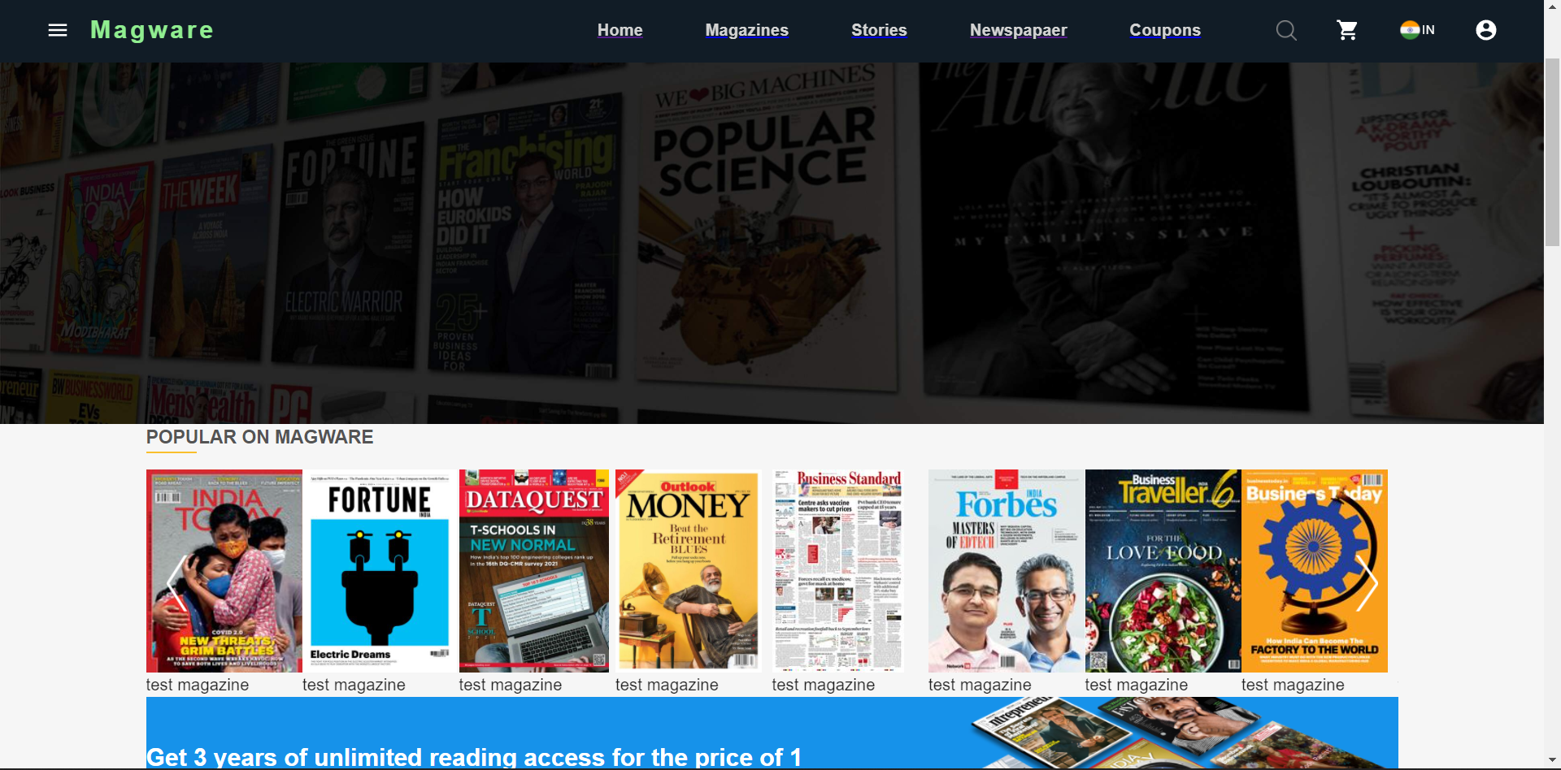

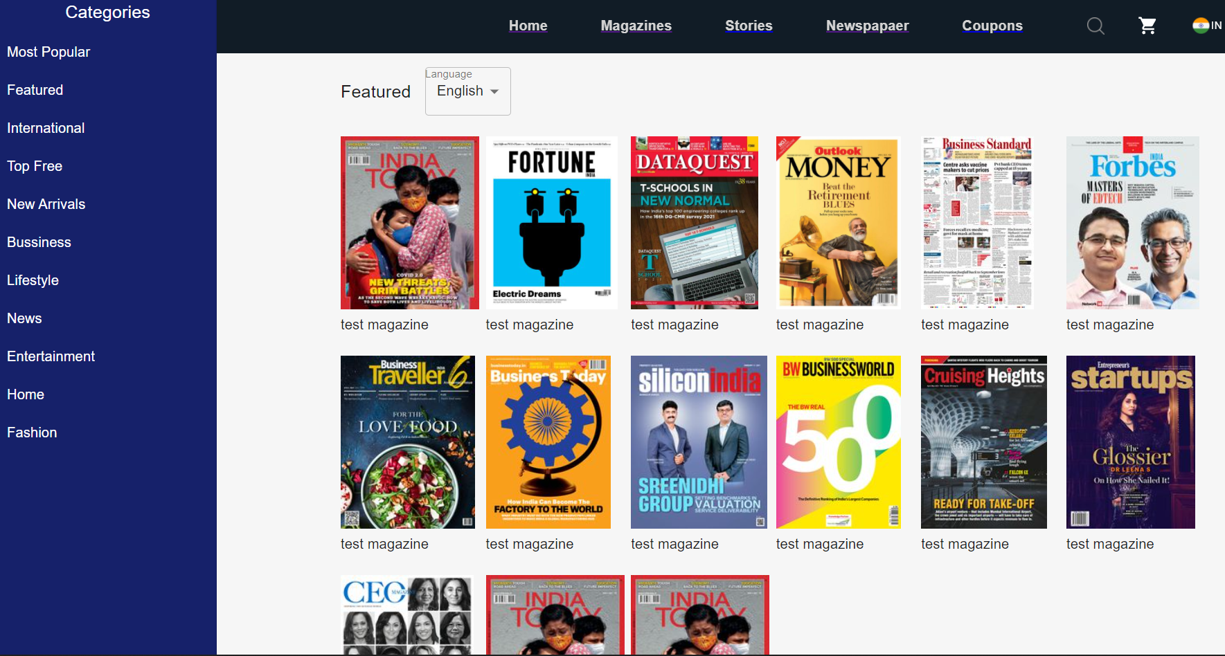

**Transreporter**

TransREporter is a bi-monthly magazine launched in 2006 with an aim to offer a source of news and knowledge to logistics professionals. TransREporter focuses on providing its point of view on industry trends, the health of the industry and various other reports and analysis necessary for logistics professionals.

So my task was to use the existing code and refactor it so that we can incorporate the 3rd website from a single codebase.Yes there was a single codebase which was responsible for 3 websites,this was achieved using the concept of theme we have different theme options based on the different website.This task was simple and quite interesting because of the way the codebase is structured.The data that is sent is different for different website this was distinguished using the origin name and we get different data for each website.

The other websites are

FHM India

L'officiel

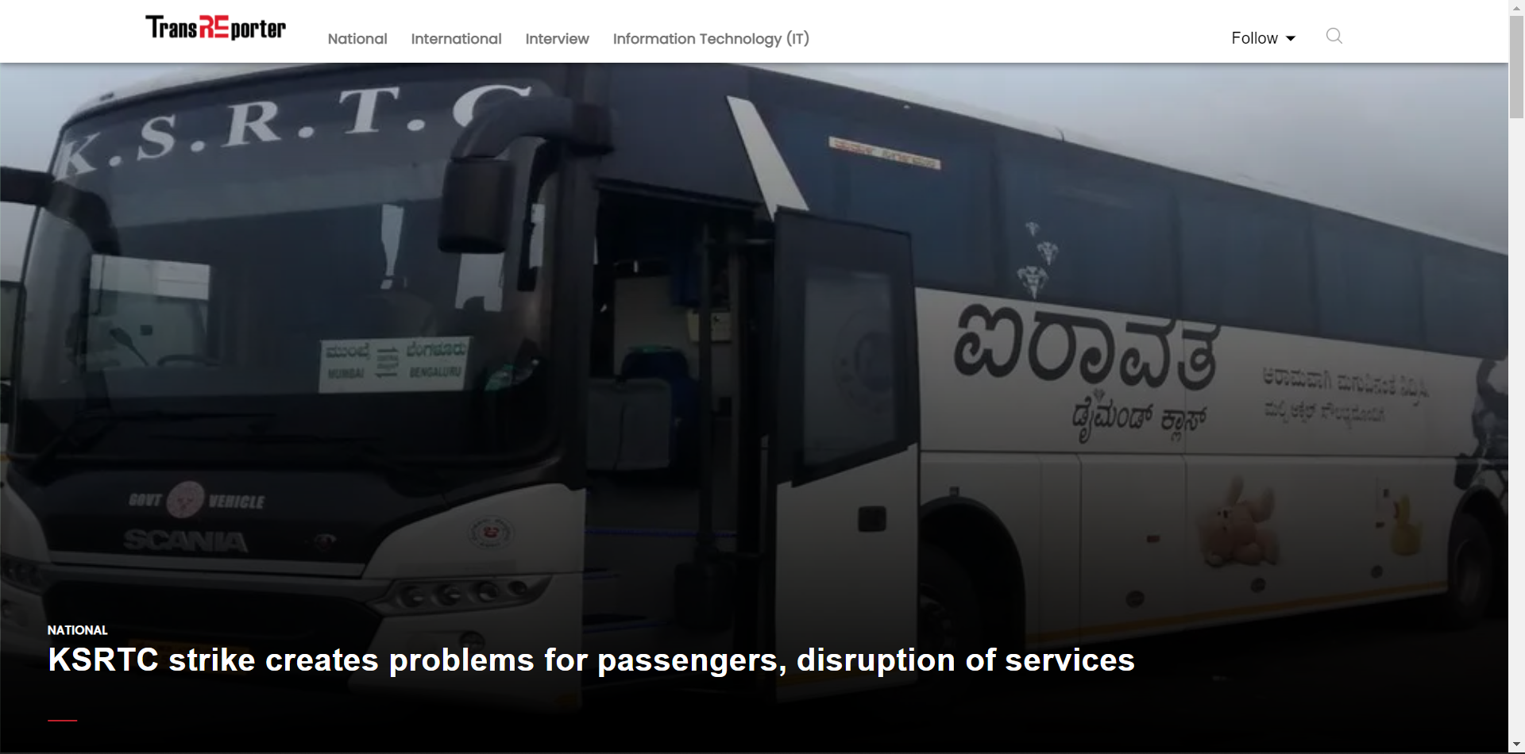

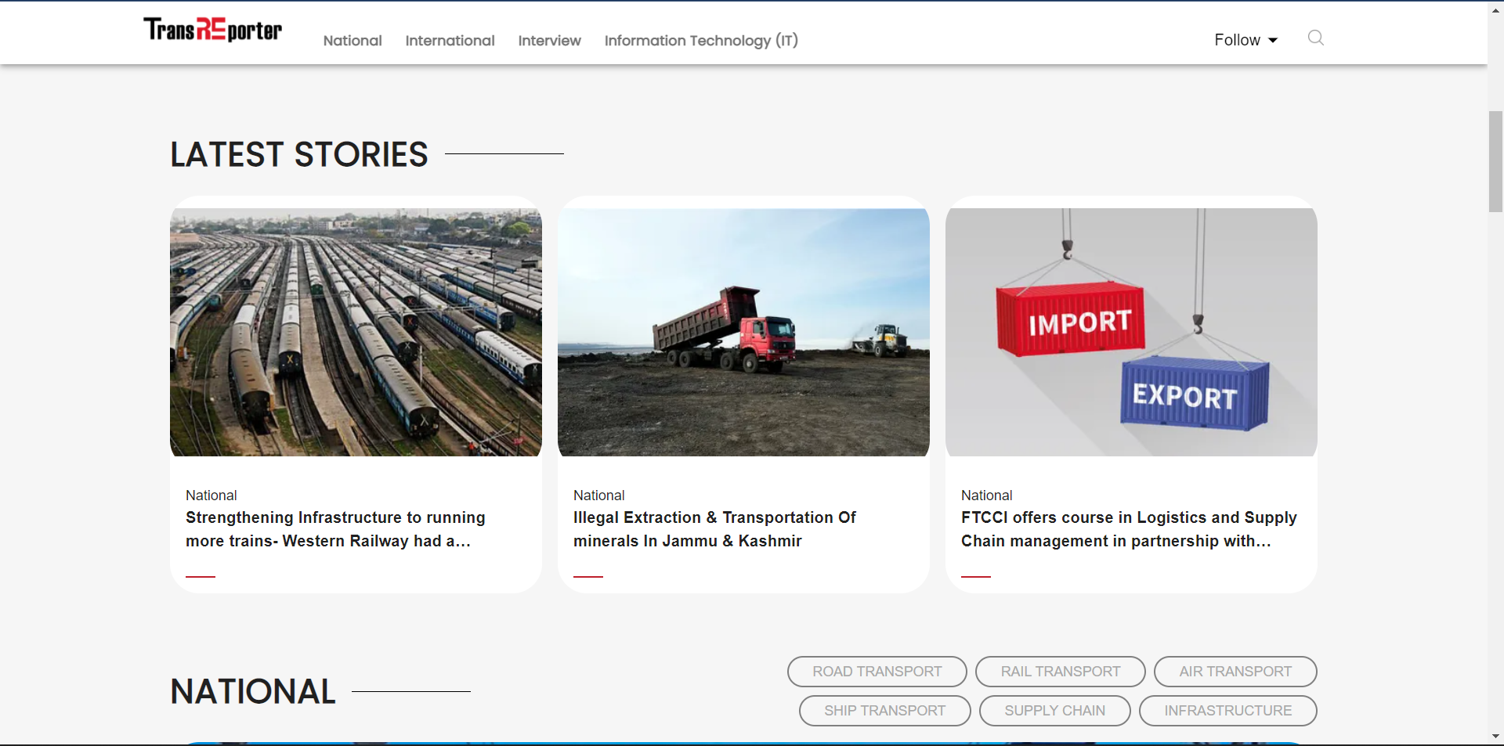

**Website Link:**

<https://transreporter.com/>

**Payment Gateway For FHM Hot 100**

This was an influencer website where influencers can register and login and can participate in polling where the users can vote for their favorite influencer.

They needed the payment gateway at the time of registration,

So I worked on the payment Gateway(Razorpay) for that influencer website.

It was a challenging task as I was very new to it and I have referred to blogs to know and completed the task and now it is live and accepting the payments.

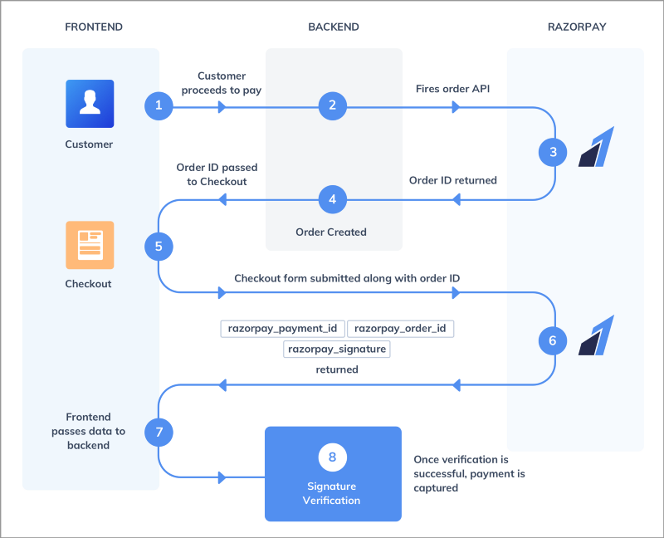

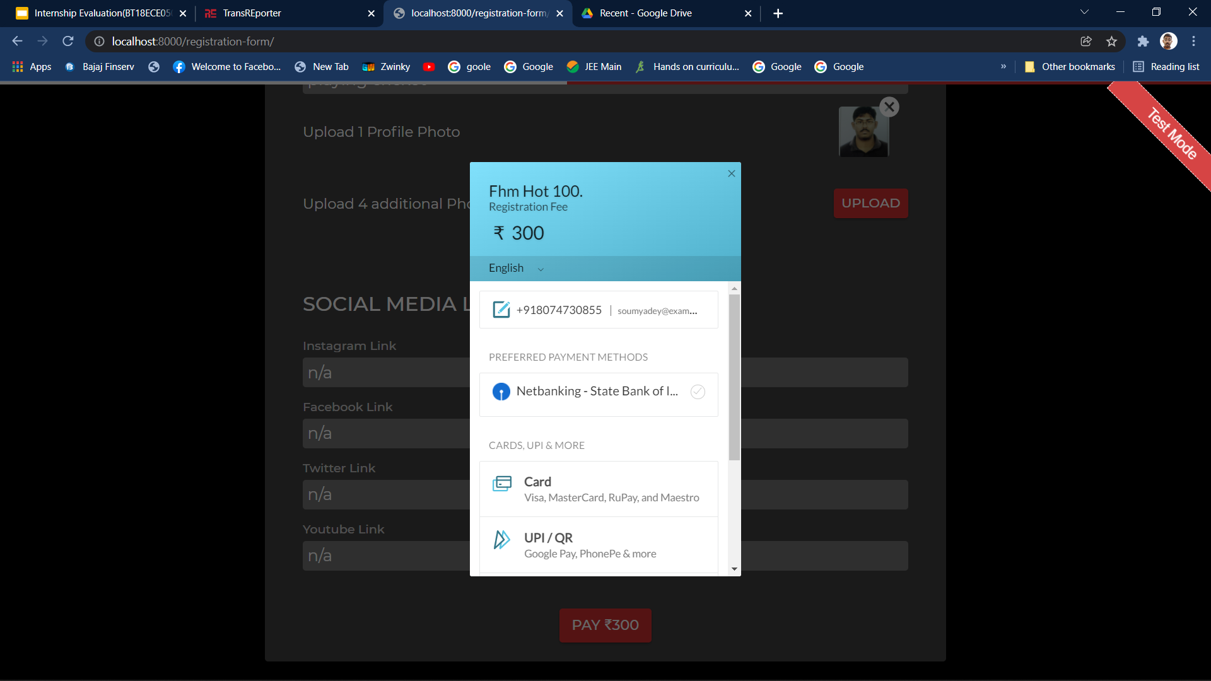

**Major Project:**

**Salt**

Salt provides businesses with a one-stop portal to manage multi-currency accounts, payments, collections, and expenses worldwide.

Salt is a neo-banking experience created to cater to international businesses. We specialize in cross border payments and banking services.

Salt is blurring the global barriers to internal transactions with its unique product offering around expense management, sending and receiving overseas money, invoicing solutions, and software to take care of legal jargon. Salt builds and delivers it all.

We aim to make international businesses a better experience for everyone and remove the barrier to entry and operating.

We want finance to be a seamless, accessible experience for everyone. Simultaneously, we take care of regulations, forex, complex codes, and crossing the international barriers for you in the background at the most feasible rate.

We want you to have the most relaxed experience while running your business.

So Initially We planned the task among oversolves and divided the sign up and authentication part was done by my colleague and I was Paral;ley working on the onboarding flow where the user after successful registration the user can fill all the details asked in the onboarding form.

So For this we have used the material ui components as they were production ready.The onboarding flow went through a few changes as it was reviewed by client they suggested a few ui and functional changes and we have completed the required changes as per their need.

In the sign in flow we have used the AWS-Amplify which was the authentication service proceed by the aws for user management and login and this simplified the user registration and login.

In the onboarding flow we have used the rest api provided by the backend team in order to send the entered data by user to backend and save them in Database.We can upload the Documents

Which were saved in the aws storage buckets.

After this we got time to write the test cases for the onboarding and sign up and sign flow and then we got to know the importance of the test the code we write because we make a lot of refactors and testing the code will make sure that our new changes will not break the existing functionality.

After completing this we have received the feedback from clients to incorporate the new changes like changes in the onboarding and sign in and sign up flow which we have completed them.

Next set of tasks were to pick up the accounts and transactions flow from the mock provided to us by the client.

The accounts flow was in continuation after the onboarding flow in between there was the verification state where the users details are verified and then next they are allowed to access the account page.

Accounts flow went through a lot of changes,So finally they decided that after the user is onboarded successfully they are given a default primary account.

Users can make any number of collections accounts receiving the money from different currencies.The entire accounts were provided by the **NIUM**.

**Nium** is a next-generation financial services platform  that enables companies around the world to unlock new revenue opportunities and improve cash flow economics.

**Nium** is a leader in its geographical and payment service breadth, owning licenses in the world’s largest and fastest-growing economies. Our modular platform allows banks, payment providers, travel companies, and other businesses to collect and disburse funds in local currencies to over 100 countries, plus issue physical and virtual cards globally. Our proprietary set of APIs embeds financial services and can bring to life multiple B2B and B2C use cases in a matter of weeks.

So We have gone through many iterations for changes for accounts flow because they wanted to make the accounts flow generic i.e not depend on any account provider example nium.We have also tried to incorporate the ICICI into the accounts flow.

So before I complete my internship I was working on the transactions flow where we create a table of transactions.At present it is only credit transactions and in future both way transactions will be enabled.The work was in progress they have instructed me to integrate the api provided by them so that they can see the list of transactions.

**We make sure that all the webpages were responsive and mobile friendly and for that we have used the rem units and css clamp method for font sizes and media queries.**

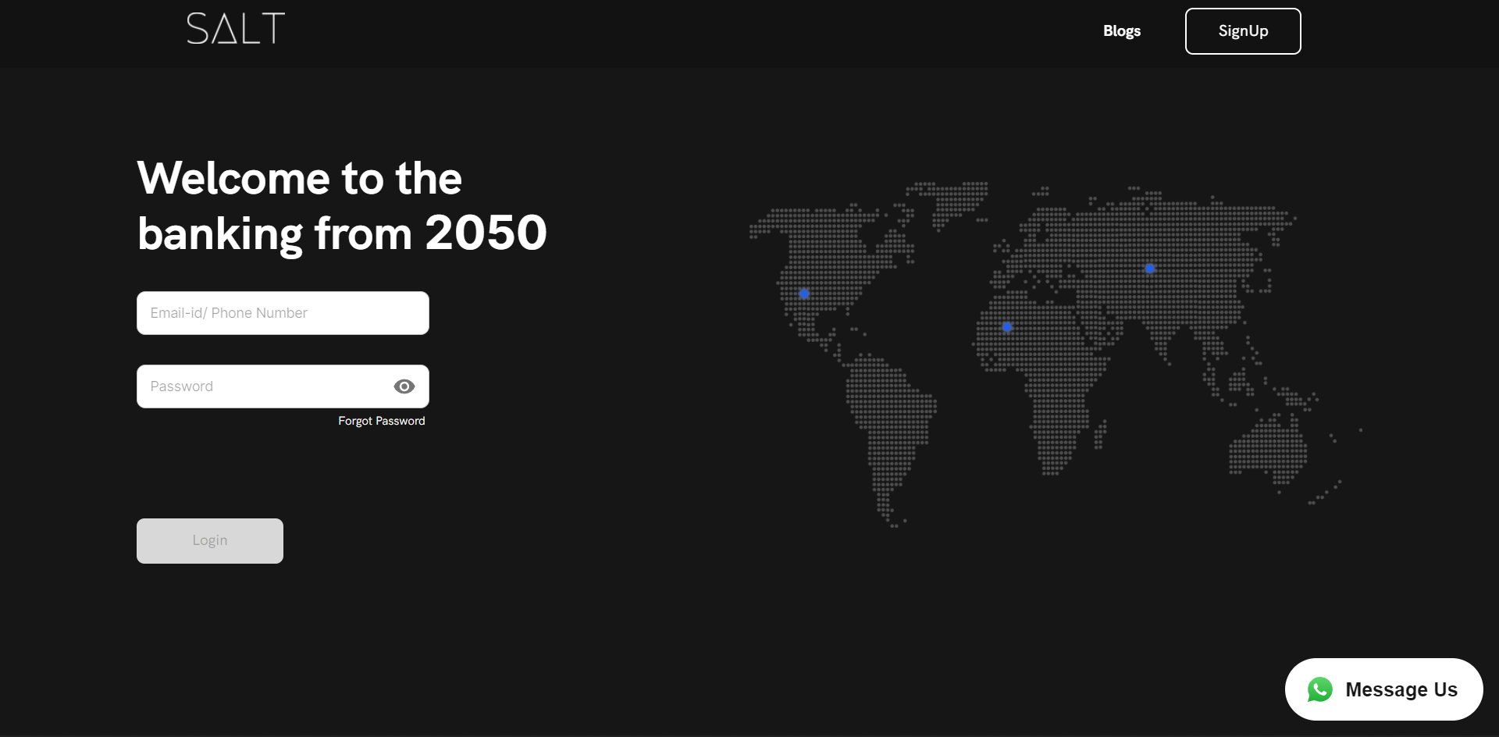

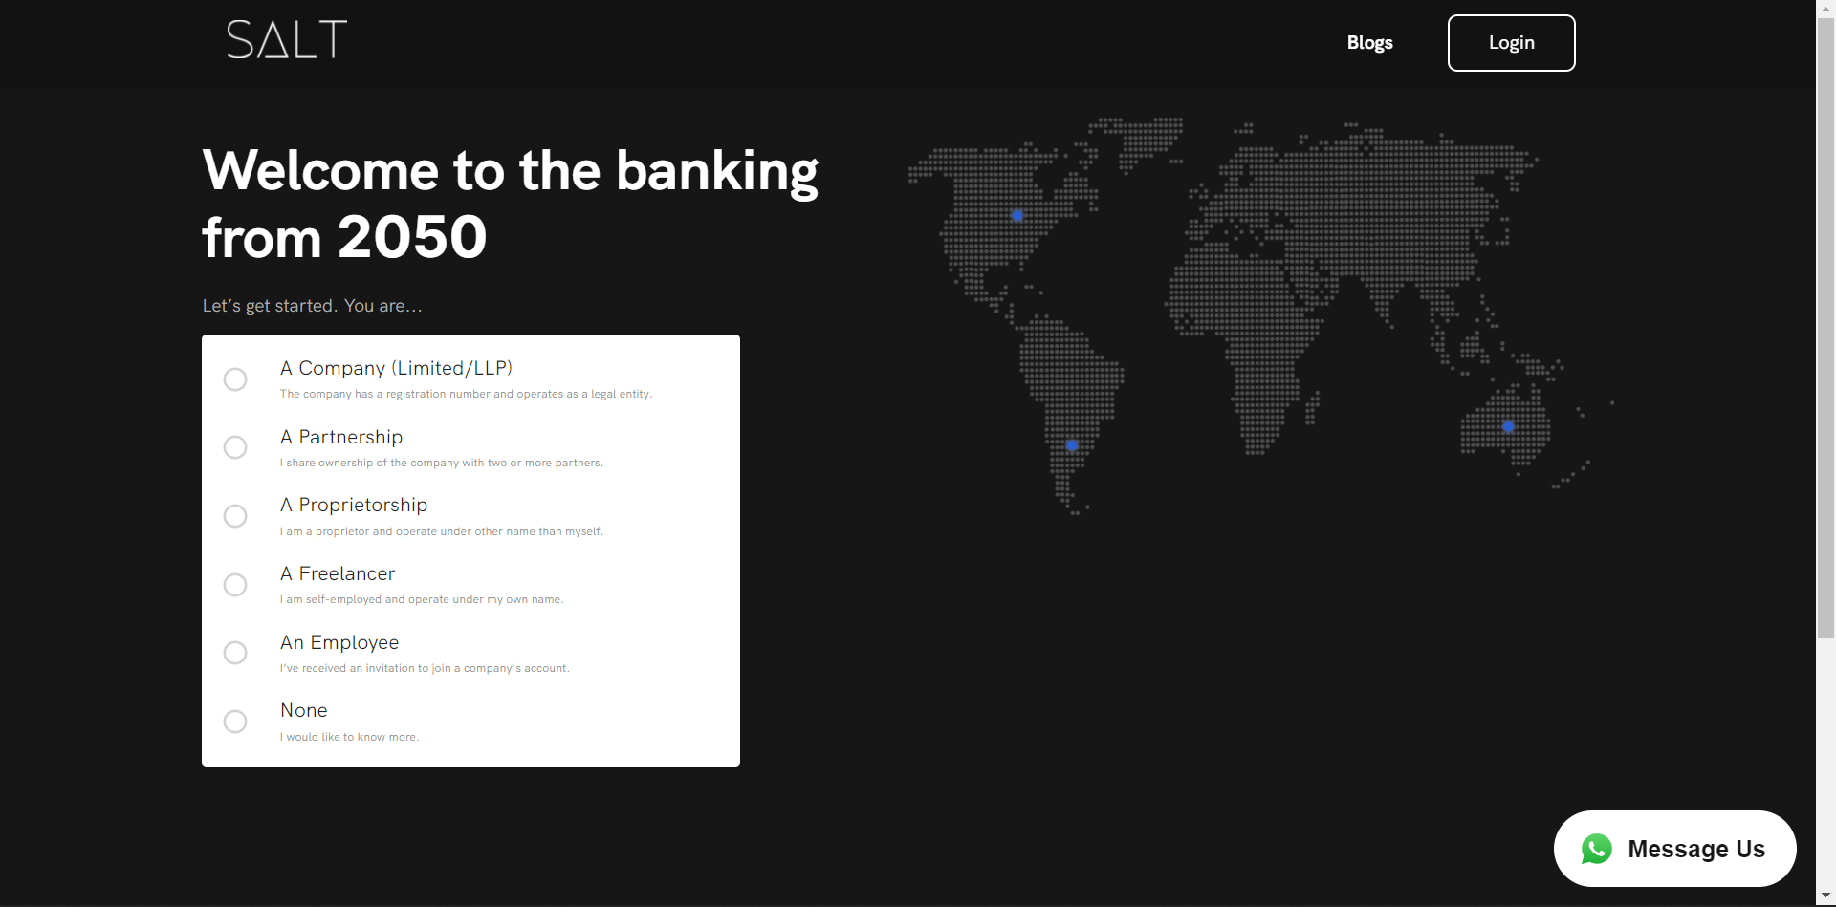

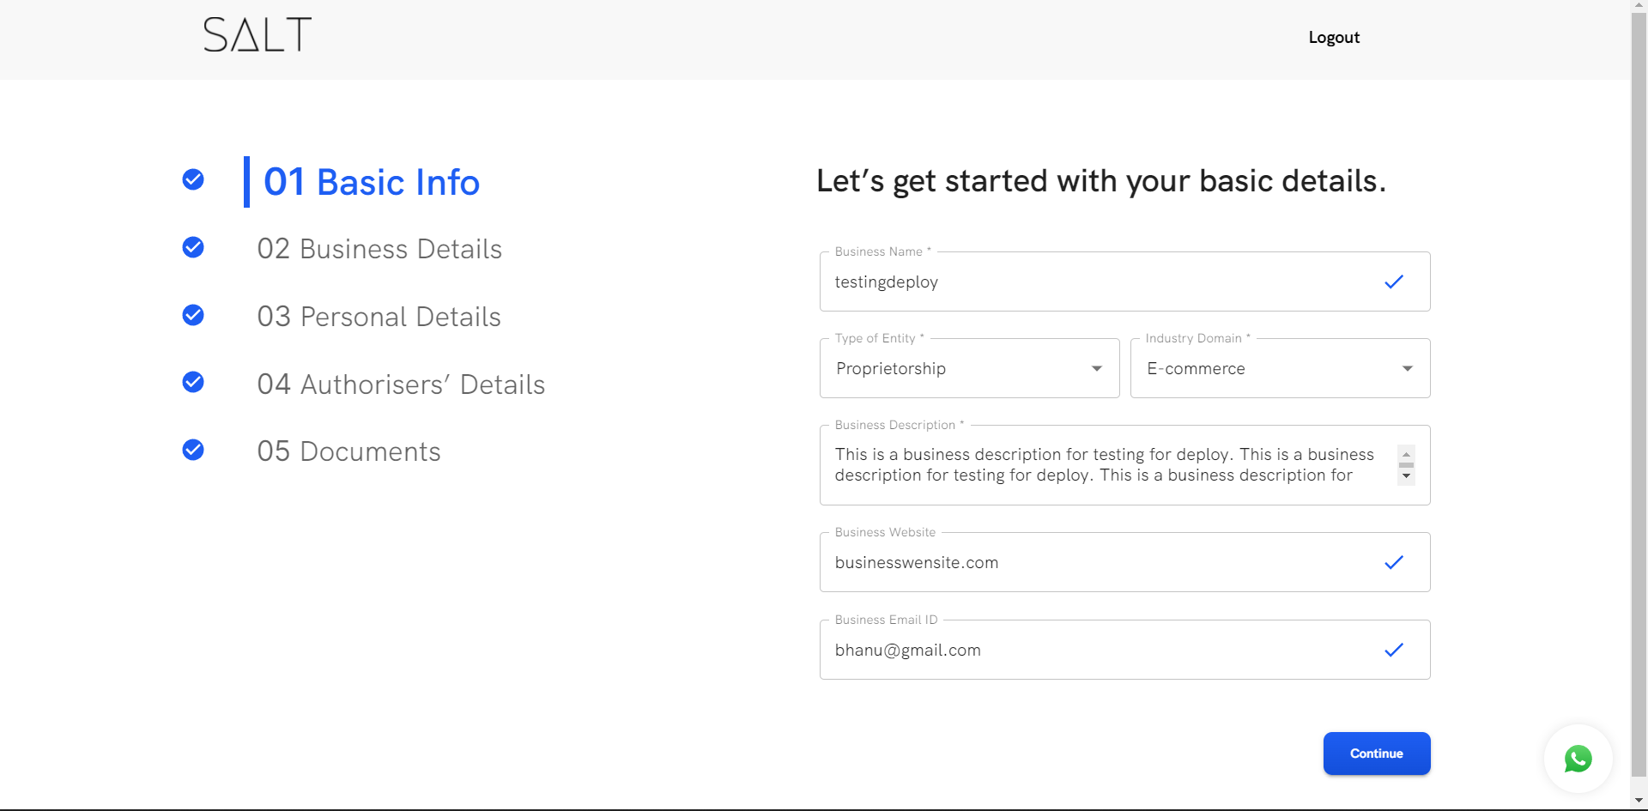

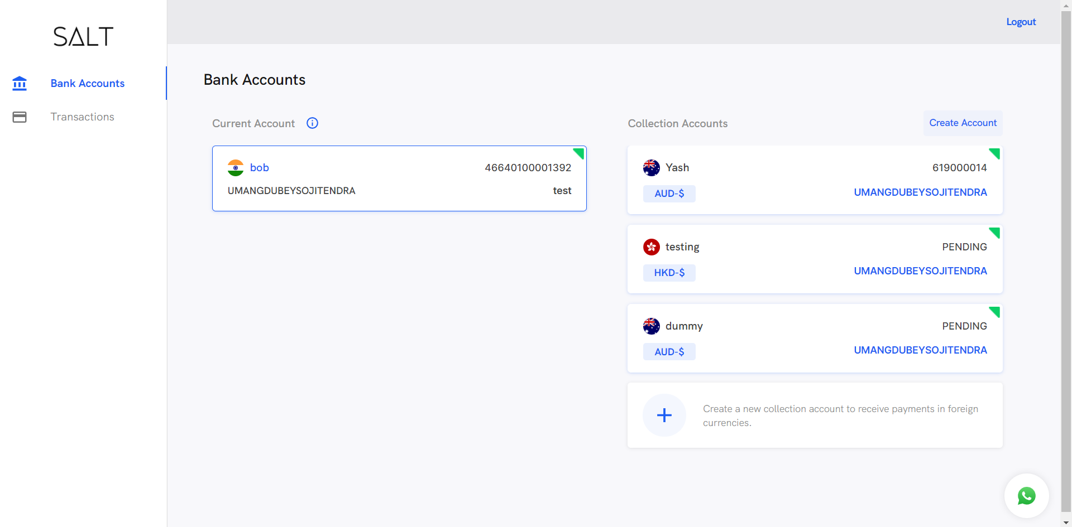

**Description of technology used**

Programming language used is javascript and the library which we are using is React.Alongside with React we also used Redux,Material UI,Redux Saga For side effects like api consuming.

Because of working with these technologies Now I got a good understanding of these and am able to develop the products from scratch.

**React**-A JavaScript library for building user interfaces.

1. **Declarative:**

React makes it painless to create interactive UIs. Design simple views for each state in your application, and React will efficiently update and render just the right components when your data changes.

1. **Component-Based and Learn Once:**

Build encapsulated components that manage their own state, then compose them to make complex UIs.

1. **Learn Once Write Anywhere:**

We don’t make assumptions about the rest of your technology stack, so you can develop new features in React without rewriting existing code.

**Redux**-A Predictable State Container for JS Apps

1. **Predictable**:

Redux helps you write applications that behave consistently, run in different environments (client, server, and native), and are easy to test.

1. Centralized:

Centralizing your application's state and logic enables powerful capabilities like undo/redo, state persistence, and much more.

1. Debuggable

The Redux DevTools make it easy to trace when, where, why, and how your application's state changed.

1. Flexible:

Redux works with any UI layer, and has a large ecosystem of addons to fit your needs.

**Material UI**-Extensive library of React components, ready for production

MUI provides a robust, customizable, and accessible library of foundational and advanced components, enabling you to build your own design system and develop React applications faster.

MUI offers a wide variety of high quality components that have allowed us to ship features faster. MUI has been used by more than a hundred engineers in our organization.

**Redux Saga:**

An intuitive Redux side effect manager.

Easy to manage, easy to test, and executes efficiently.

### **Asynchronous**

ES6 generators make asynchronous flows easy to read, write, and test. Create complex side effects without getting bogged down by the details.

### **Composition-focused**

Sagas enable numerous approaches to tackling parallel execution, task concurrency, task racing, task cancellation, and more. Keep total control over the flow of your code.

### **Easy To Test**

Assert results at each step of a generator or for a saga as a whole. Either way, side effect testing is quick, concise, and painless, as testing should be.

**Axios:**

Promise based HTTP client for the browser and node.js

**AWS Amplify:**

**Build extensible, full-stack web and mobile apps faster. Easy to start, easy to scale.**

AWS Amplify is a set of purpose-built tools and features that lets frontend web and mobile developers quickly and easily build full-stack applications on AWS, with the flexibility to leverage the breadth of AWS services as your use cases evolve. With Amplify, you can configure a web or mobile app backend, connect your app in minutes, visually build a web frontend UI, and easily manage app content outside the AWS console. Ship faster and scale effortlessly—with no cloud expertise needed.

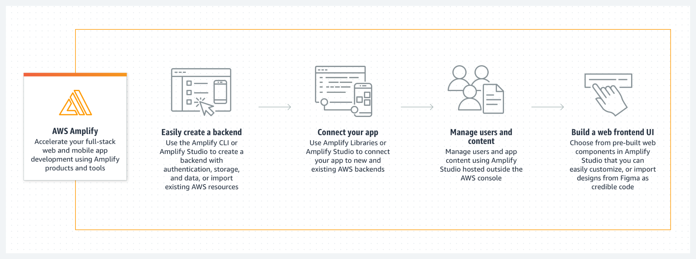

React-Redux:

Official React bindings for Redux

Rest API:

Rest API was provided to us by the backend team which we used by redux saga along with axios to fetch the data from backend.

**Industrial/Commercial applications of project**

**Borderless Banking**

Salt is a neo-banking experience created to cater to international businesses. We specialize in cross border payments and banking services.

Salt is blurring the global barriers to internal transactions with its unique product offering around expense management, sending and receiving overseas money, invoicing solutions, and software to take care of legal jargon. Salt builds and delivers it all.

**Productivity tools**

**VS Code :**

Visual Studio Code is a free source-code editor made by Microsoft for Windows, Linux and macOS. Features include support for debugging, syntax highlighting, intelligent code completion, snippets, code refactoring, and embedded Git. It also contains extensions developed by the open source community to add various features such as dynamic type checking for typescript, and code prettier which maintains the indentation of the code.

**Github:**

GitHub, Inc. is a provider of Internet hosting for software development and version control using Git. It offers the distributed version control and source code management functionality of Git, issue-tracking and continuous integration and deployment pipeline features. This was used to manage all our repositories online.

**Flock:**

Flock is a proprietary messaging and collaboration tool, founded by tech entrepreneur Bhavin Turakhia in 2014. The app is available on Windows, MacOS, Android, iOS and Web. Flock allows users to configure external apps and integrations from the Flock App Store, and receive notifications and updates directly in Flock.

**Flock was a tool we used for internal communication and discussions.**

**Adobe Xd:**

Adobe XD is a vector-based user experience design tool for web apps and mobile apps, developed and published by Adobe Inc. It is available for macOS and Windows, although there are versions for iOS and Android to help preview the result of work directly on mobile devices.

**Figma:**

Figma is a vector graphics editor and prototyping tool which is primarily web-based,

with additional offline features enabled by desktop applications for macOS and

Windows. The Figma Mirror companion apps for Android and iOS allow viewing

Figma prototypes on mobile devices.

**We have used it to see the prototypes and mockups and from those we have converted the mockups to the actual web pages using React.**

**GSuite:**

G Suite is a collection of cloud computing, productivity and collaboration tools, software and products developed and marketed by Google. This was used to store all files on the drive and Google Docs to maintain informal internal documentation for all our code.

**Prettier:**

An opinionated code formatter which Supports many languages and Integrates with most editors

You press save and code is formatted ,No need to discuss style in code review and Saves you time and energy.

**Github Copilot:**

This I have started using after 3 months of my internship because then only i got the access.

Your AI pair programmer

With GitHub Copilot, get suggestions for whole lines or entire functions right inside your editor.

GitHub Copilot is powered by Codex, the new AI system created by OpenAI. GitHub Copilot understands significantly more context than most code assistants. So, whether it’s in a docstring, comment, function name, or the code itself, GitHub Copilot uses the context you’ve provided and synthesizes code to match. Together with OpenAI, we’re designing GitHub Copilot to get smarter at producing safe and effective code as developers use it.

**Certificate done/Training attend at organization during internship**

As such we were not trained by the company on all the technologies I have learned through the courses and internet.

During the joining we were guided by the senior developers about the codebase and how to understand the components and functions used in the codebase.

But There was constant support from the company and team mates to help each other when we were stuck with something.

**Challenges faced during the internship and ways sought to overcome challenges.**

**Fast paced development**

This was one of the biggest challenges I faced during my internship. All things were moving very fast and it was difficult to keep up. It was resolved gradually as I started to pick up my pace and gradually got used to the pressure and speed.

**Reading documentation**

Many of the tools/libraries online have youtube tutorials or some blogs on it to explain the new users/developers. But learning new libraries without any youtube tutorials or blogs was a difficult process for me. I had to learn how to read documentation and read the code and how to use it. It took me a lot of overtime and effort to learn how to read the documentation efficiently.

**Difficulty in discussion**

At first, it was very difficult for me to mention the issues I’m facing and contacting the senior developer for issues that seemed small to me, but were difficult. I could not write good code and was in a constant battle with myself about spending time on good quality code or completing it fast.

I walked up the courage to talk to my senior dev about it, and he was very supportive about it. He told me to write the code as I saw it right, and he would review my code every weekend. Also, he made me realize that by not asking questions, I’m just wasting everyone’s time and resources and that I should ask something if I’m stuck on it for a significant amount of time

**Five learnings from internship**

1. **Team Work (Scrum and Team meetings Everyday)**

We were a small team of 13 people who were very much interested in product building from development to deployment.We enjoyed discussing the tasks in the daily morning scrums and google meet whenever necessary to discuss any new approach or solve the problems.

1. **Improving the communication skills**

Communication is the only thing that keeps a team together and working efficiently.

1. **Time Management**

Managing personal and professional life and creating a balance between them is very important, and it can only be learnt over time with experience

1. **Learn Various Frontend Technologies**

Frontend development has evolved a lot and it is not just HTML and CSS anymore. There are a vast amount of frameworks and libraries such as React, Angular, Vue which are categorized as frontend and knowing how to use them without writing much CSS is also a great skill in itself.

1. **Version Control**

Learned how to use git and all its important features which are used excessively in the industry such as merging, branching, pull requests, etc.

1. **Using tools to write clean and maintainable code**

I learned that using tools like prettier, husky, and many others, it’s possible to write clean and good code without worrying too much about small things all the time. There are a lot of good software written to do this stuff for you.

1. **Writing tests**

The importance of writing tests in the real world is too much. Writing unit tests is a very valuable skill to have, and it also prevents pushing some very minor wrong code with a huge side-effect to the server/production. These prevent a lot of mishaps in the real world..

**References:**

**Salt:**

<https://app.salt.pe/signup>

**Transreporter:**

<https://transreporter.com/>

**Magware:**

<https://magware.netlify.app/>